**LOGICAL OPERATIONS**  
  
  
  
  
  
**EXP NO: 20**  
  
  
  
  
  
**AIM:**To compute various logical operations  
using 8085 processor.  
  
  
  
  
  
  
  
  
  
  
  
**ALGORITHM:**  
  
  
   
  
  
1)      Load data to accumulator.  
  
  
2)      Load another data in register  
  
  
3)      Perform logical operations like AND, OR and XOR (Use ANA,  
ORA, XRA) with the accumulator content.  
  
  
4)      Store the result in specified memory location.  
  
  
 

**PROGRAM:**

**AND OPERATION:**  
  
MVI A,06

MVI B,04

ANA B

STA 2500

HLT

**OR OPERATION:**

MVI A,07

MVI B,06

ORA B

STA 2000

HLT

**XOR OPERATION:**  
  
  
MVI A,03

MVI B,08

XRA B

STA 2000

HLT  
  
   
  
**AND OPERATION:**  
  
**INPUT:**

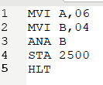  
**OUTPUT:**

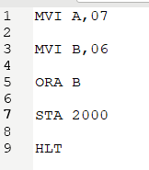

**OR OPERATION:**

**INPUT:**

  
  
**OUTPUT:**

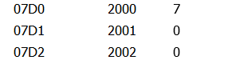

**XOR OPERATION:**  
  
**INPUT:**  
  
  
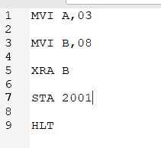  
  
  
  
**OUTPUT:**  
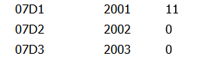  
  
  
  
  
  
**RESULT:**Thus the program was executed successfully using 8085  
processor simulator.